January/February Good News 2023
Our ministry vision for the Virginia Annual Conference is “to be disciples of Jesus Christ who are lifelong learners, who influence others to serve.”
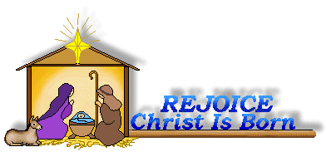
From Pastor Adam
“Something New”
In the time of King Herod, after Jesus was born in Bethlehem of Judea, wise men from the East came to Jerusalem, asking, “Where is the child who has been born king of the Jews? For we observed his star at its rising, and have come to pay him homage.”
When they saw that the star had stopped, they were overwhelmed with joy. On entering the house, they saw the child with Mary his mother; and they knelt down and paid him homage. Then, opening their treasure chests, they offered him gifts of gold, frankincense, and myrrh. (Matthew 2:1-2, 10-11)
When he came to Nazareth, where he had been brought up, he went to the synagogue on the sabbath day, as was his custom. He stood up to read, and the scroll of the prophet Isaiah was given to him. He unrolled the scroll and found the place where it was written: “The Spirit of the Lord is upon me, because he has anointed me to bring good news to the poor. He has sent me to proclaim release to the captives and recovery of sight to the blind, to let the oppressed go free, o proclaim the year of the Lord’s favor.” And he rolled up the scroll, gave it back to
the attendant, and sat down. The eyes of all in the synagogue were fixed on him. Then he began to say to them,
“Today this scripture has been fulfilled in your hearing.” (Luke 4:16-21)
We celebrate the arrival of the magi or wise men on the feast of the Epiphany (January 6). The magi were Persian philosophers and teachers who followed the star in the pursuit of wisdom – divine wisdom revealed in the Christ child. The arrival of the magi shows that God is beckoning all people into relationship with God through Christ. This message is not unique to Israel or Palestine or the Ancient Near East, but it is meant for the whole world -it is Good news for the entire human race in all times and places. Central to Epiphany is the idea that the divine nature of Jesus is being “disclosed, revealed, discovered, and manifest” (after all, these are all
appropriate interpretations of the word “epiphany”). We use the same language in common parlance when we describe an important personal discovery as being an “epiphany for us.” The recommended scripture lessons for the Sundays following the Epiphany also carry on the theme of disclosing and revealing Jesus’ divine nature even as he grows into adulthood. This year the lessons will include events like Jesus’ baptism and the heavenly voice declaring that he is God’s Son, Jesus turning water into wine, and even the passage mentioned above, when Jesus demonstrates that the writings of the prophets (like Isaiah) all foretell his healing, saving, and
liberating work as God’s Messiah. In Christ, God is doing a new thing – a new revelation, a new disclosure of truth, a new manifestation of God’s goodness, glory, and truth. I pray that this time between the Epiphany (January 6) and the arrival of Lent on Ash Wednesday (February 22) will be marked with newness for us – that in these days we will hear God’s voice in new and clear ways, that we will have a new awareness of God’s presence and love, that we will see new opportunities for service and compassion, and that the Spirit of God would touch the stale places of our hearts and lives and infuse us with new life and purpose. In other words,
may you have an “epiphany” during this season of Epiphany!
~God bless you my friends, Adam

Circle News
* * * * * * * * * * * * * * * * * * *
The Merry Marthas Circle will meet on Wednesday, January 11th, at church, at 10:00 a.m. in the social hall. We will have a program and offering for Prayer and Self-Denial, followed by a business meeting. Judy will provide soup for lunch. Let me know if you can help by bringing salad or drink.
Our February 8th meeting will be our "Valentine Lunch" at Charley's Restaurant. We will meet at Charley’s at 11:30 a.m.
~ The Wesleyan Group will resume in March.

Mission Memo
In December we donated 49lbs. of food and 129lbs. of cleaning products to Park View Community Mission. This helped provide a holiday meal for the clients and products for cleanup after. The mission committee thanks everyone who faithfully supported this mission during the past year. We hope to continue the support in the new year.
For January and February PVCM has requested fruit and vegetables in pop top cans. Also they are in need of hygiene products. Toothpaste, mouthwash, deodorant, soap, body wash, lotion, shampoo & conditioner,and feminine protection products.
~Thank you the Mission Committee

Food Cart...
Items needed for the Food Cart for Park View Community Mission.
For the Month of January/February
Fruits/Vegetables (poptops), hygiene products such as: soap/bodywash, shampoo, lotion, deodorant, toothpaste/mouthwash, razors, shaving cream, and feminine products.
Place donations in the grocery cart, located in the Commons. No “baked goods” of any kind.

Beryl Elizabeth Martin
September 21, 1926 - December 19, 2022
Chestnut Hill United Methodist Church extends Christian love and sympathy to the family of Beryl Elizabeth Martin and
especially to her nephew, Bill Graham, and her sister-in-law, Margaret Martin.

Stewardship Luncheon
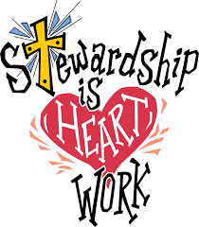
On Sunday, February 12, we will celebrate our Stewardship (pledges) to CHUMC for 2023 (and Valentine's Day) with a luncheon after church. We still have some church funds available, so this will be a catered meal. Just come and enjoy! If you have not yet made a pledge and would like to do so, it's never too late!
**NOTE: This event is subject to change if bad weather occurs.

We are un-decorating our church on Saturday, January 7, 2023, at 9:30 a.m. Let Judy Robertson know if you can help.

“Thank you”
Dear Chestnut Hill Congregation…
Just wanted to thank you all for the telephone calls and beautiful get well cards I have received since my three month absence from church. I’m improving slowly and Rebecca and I hope to join you all again very soon. Can’t forget also the wonderful visit both of us had with our wonderful, thoughtful Pastor Adam White.
~Yours in Christ, Tucker & Rebecca Cole

Dear Chestnut Hill UMC Members:
We are thankful for your very generous donation to the “Ways to Work Angel Tree” program. With your help we are able to meet the needs of many families who need Christmas gifts for their children in our community. As you may already know, our program provides more than financial literacy education and low interest care loans. We also help families who need support with household cleaning supplies, hygiene items, and food. With your help we will continue to serve people who are part of our workforce in the community. We hope you all have a wonderful Christmas season.
~In Gratitude, “Ways to Work” Staff

CHUMC,
I am humbled by your generous gift. Thank you so much for thinking of me. I love working with all of you and being able to see you all each Sunday. I hope you have a very blessed Christmas and a wonderful New Year!
~Heather Wilson

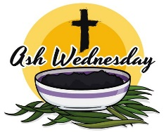
Join us on Wednesday, February 22, 2023, for our Ash Wednesday Service, at 5:00 p.m.

Lay Servant Academy is excited to share its Winter Training that will take place on Friday and Saturday, February 17th & 18th. The course schedule features Michael Beck, originator of Fresh Expressions and a leader in cultivating movements. In addition to this course in Planting Fresh Expressions, additional courses include Fruitful Small Groups, Lay Pastoral Care-Giving, Basic Course, Spiritual Gifts, and Certified Lay Ministry Orientation. Courses are offered in person only at Shady Grove UMC Mechanicsville, VA. Registration and additional information can be found using this link: https://vaumc.org/layservantacademy/
For questions, you are welcome to email Tianna Durbin, Director of Lay Servant Academy.

1 Autumn
Hendricks
2 Andrea Baughman
3 Rebecca Beiler
5 Kayleigh
Morris
7 David
Maxham
11 Debra
Higginbotham
Maris Tiller
13 Lanie Jay
Barbara
Murrell
Kirsten Tiller
15 Ted Stables Steve Stadtherr
16 Bob Elium
23 Ty Burgess
25 Elaine Clarke
Ian
Richardson
Jan Wiley
26 Donald Yost
28 Charles Moore

2 LeAnn Glass
Brenda Torian
5 Gloria Coleman
6 Brenda Lyons
8 Hylton Glass
9 Samantha Allen
Warren Cole
Micajah Mason
Helen Snow
12 Tara Collins
13 Ruth Ann
Harris
14 Jennifer Witt
15 Carl Yates
16 Jeanette Levin
18 Tatum Burgess
Taylor
Hendricks
20 Jeremy
VandeBogart
23 Aaron Yost
25 Annette Stadtherr
29 Laura Woolley
30 Margaret
Johnson

2023

Sunday | Monday | Tuesday | Wednesday | Thursday | Friday | Saturday
1 Epiphany Sunday  9:30am Sunday School  10:30am Worship | 2 | 3  6:30pm Homeschool Game Night | 4 | 5  6:30 pm  Choir | 6 | 7  9:30 am  Un-decorating Church
8 Baptism of the Lord  9:30am Sunday School  10:30am Worship | 9 | 10  6:30pm Homeschool Game Night | 11  10:00am Merry Martha's Circle | 12 | 13  Office Closed  10:00am Homeschool | 14
15 Second Sunday after the Epiphany  9:30am Sunday School  10:30am Worship | 16  Office Closed | 17  6:30pm Homeschool Game Night | 18 | 19 | 20  10:00am Homeschool | 21
22 Third Sunday after the Epiphany  9:30am Sunday School  10:30am Worship | 23 | 24 | 25 | 26 | 27  10:00am Homeschool | 28  7:00pm Homeschool Winter Formal
29 Fourth Sunday after the Epiphany  9:30am Sunday School  10:30am Worship | 30 | 31

2023

Sunday | Monday | Tuesday | Wednesday | Thursday | Friday | Saturday
 |  |  | 1 | 2 | 3  10:00am Homeschool | 4
5 5th Sunday after Epiphany  9:30am Sunday School  10:30am Worship | 6 | 7  6:30pm Homeschool Game Night | 8  11:30 am Merry Martha's Circle@  Charley’s | 9  6:30 pm  Choir | 10  10:00am Homeschool | 11
12 6th Sunday after Epiphany  9:30am Sunday School  10:30am Worship  11:45am Stewardship Luncheon | 13 | 14  6:30pm Homeschool Game Night | 15 | 16 | 17  10:00am Homeschool | 18
19 Transfiguration Sunday  9:30am Sunday School  10:30am Worship | 20  Church Office Closed | 21  6:30pm Homeschool Game Night | 22  5:00pm Ash Wednesday Service | 23 | 24  10:00am Homeschool | 25
26 1st Sunday in Lent  9:30am Sunday School  10:30am Worship | 27 | 28

1 Pat Short
2 Nancy Lee
Emily V.
Fernandez
3 Michael McGlothlin
6 Kirsten Bell
Tim Crist
Dennis Tolley
7 Kenny Busic
Cheryl Powell
9 Owen Stinnette
Jeremey
VandeBogart
11 Landen Glass
12 Camden Mason
14 Wade Ware
16 Burton Brooks
Terry Palazzi
Anne-Elaine Tiller
17 Suzanne
Marshall
Blake Phillips
18 Sharon
Rickmon
19 Connie Yost
20 Erin Ecklund
21 Steven Kinzer
22 C.O. Bell
25 Frankie
Hardwick
28 Jacqueline Busic
Cheryl Thomas
29 Wes Robbins
Ricky Smith
31 Robert Baunach

2022
Those Who Serve~January  GREETERS:  January 1 ~ Ann Robbins  January 8 ~Maggie Musgrove  January 15 ~Jane White  January 22 ~Mary Walker  January 29 ~Dan Robertson  Those Who Serve~February  GREETERS:  February 5 ~Betty Taylor  February 12 ~Ann Robbins  February 19 ~Judy Robertson  February 26 ~Jane White  + + + + + + + + + + + + + + + + + + + + + + +  GOOD NEWS is published monthly for members and friends of Chestnut Hill United Methodist Church. Send articles to the church office by the 15th of the month. (Subject to change.)  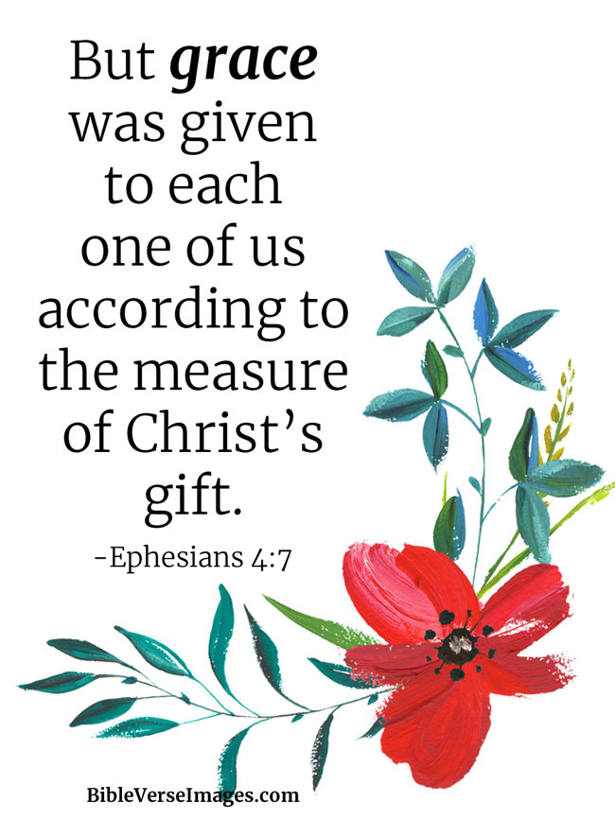  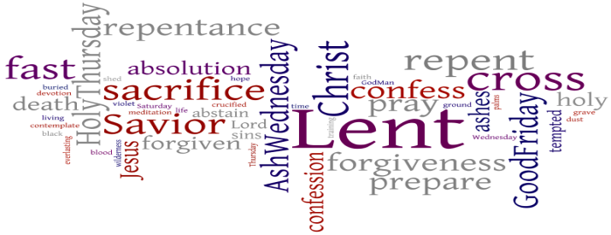 | Our Church Financial Picture  Through the end of November 2022  General Operating Funds:  Needed to meet our 2022 Budget $ 194,759.00  Needed to meet our budget to date $ 178,529.00  Actual receipts to date $ 146,026.00  Shortage to meet budget to date $ 32,503.00  Actual expenditures to date $ 151,985.00  Shortage to meet expenses to date $ - 5,959.00  Joy In Missions Funds:  Our Giving Goal for 2022 $ 11,600.00  Needed to meet our goal to date $ 10,633.00  Actual receipts to date $ 8,895.00  Special Offerings* (not budgeted):  Received to date $ 16,778.00  Dispersed to date $ 12,640.00  *Christmas, Easter, Annual Conference,  World Communion, etc.  2022 Joy In Mission Donations  To date, the following amounts have  been paid to the missions indicated.  Budget Spent  1. Missionary Covenant Relationship $1,000 $750  2. Interfaith Outreach $1,000 $750  3. Park View Mission, Food for  Families $3,000 $2,705  4. Society of St. Andrew $1,000 $500  1. Adult Care Center $ 500 $375  2. Blue Ridge Area Food Bank $ 1,000 $750  3. Camp Timothy $ 500 $500  4. Churches for Urban Ministry $ 500 $375  5. Daily Bread $ 500 $375  6. Free Clinic $ 500 $375  7. Good Neighbor $ 500 $0  8. Habitat for Humanity $ 500 $375  9. UMCOR-Non-Administrative $ 500 $0  10. Undesignated $ 600 $0  Thank You for Your Generosity

March 2022
January 2022
2022

April 2022
April 2022
March 2022

Chestnut Hill United
Methodist Church
4660 Fort Avenue, Lynchburg, VA 24502

Phone Number: 434-239-8423: FAX: 434-239-7209
E-mail: chestnuthillumc@comcast.net
On the web: www.chestnuthillumc.net

Church Office Hours
Monday-Thursday~9:00 am—3:30 pm
Friday~9:00 am-1:00 pm

DIRECTORY OF
CHESTNUT HILL UNITED METHODIST CHURCH
 | Sue Haupert-Johnson | Richmond Area Resident Bishop
 | Denise Bates | Mountain View District Superintendent
 | Adam White | Minister
 | Erin Long | Associate Minister
 | Monica C. Campbell | Administrative Assistant
 | Heather Wilson | Director of Music Ministry
 | Judy Martin | Bookkeeper
 | Judy Robertson | Lay Leader

